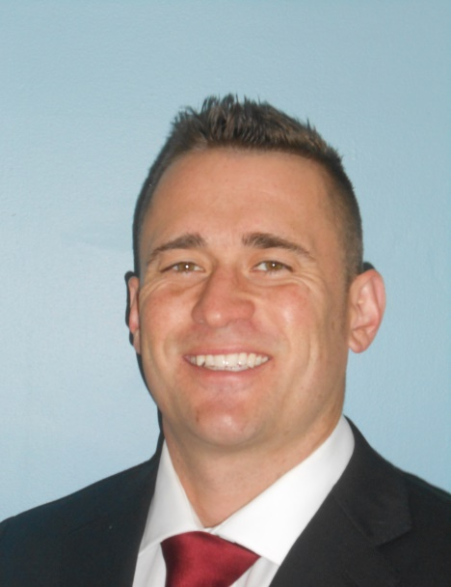
Cody Weaver Bio
Cody Weaver is rapidly emerging as one of New Jersey’s Top-Producing Business Brokers. He has an excellent sales aptitude and is highly motivated to perform above and beyond his clients expectations. His goal is to be the #1 Broker in the country(behind the legendary Mel Lisiten). Over the last several years he has proven his ability by closing numerous Multi-Million Dollar Deals.
He is an entrepreneur at heart and has found massive success in other ventures before becoming a broker. Most notably he was the President & Founder of a commodities brokerage firm that raised and managed over $50 Million in transactions. Mr. Weaver also grew up participating in his family owned company where he learned and developed great business acumen.
His prior business accomplishments highlight his immense passion for representing and negotiating for other entrepreneurs that want to monetize their hard work. Every day he is honored that you business owners and leaders trust us to work on your behalf. He pledges to use every ounce of education, training, experience and street smarts to help them fulfill their personal versions of the American Dream!
Mr. Weaver carries Bachelor’s Degree in Business Administration from F.A.U. and has a Master’s Degree in Hard Work and Dedication from the School of Hard Knocks.

