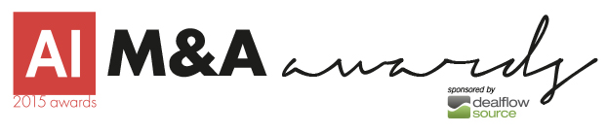

I am happy to inform you that LISITEN ASSOCIATES BUSINESS BROKERS has been nominated in the Acquisition International 2015 M&A Awards, sponsored by Dealflow Source, ‘deal flow solutions that provide institutional private company investors with improved deal flow and deal quality’.
Now in its fourth year, these global awards seek out exceptional M&A professionals and firms who have exceeded in their field in the last twelve months. We have been asking corporate professionals to cast their votes and put forward those they believe to be most deserving of recognition and we are delighted to announce that you have been put forward as a winner.

